City: London

Season: Spring-Summer

Year: 2021

Women

Ready-to-Wear

Brand Name: Christopher Kane

Designer Name: Christopher Kane

Description: People’s true colors have been coming out this London Fashion Week. Now that the shows are out and what personal contact possible with designers reduced to carefully managed COVID-secure appointments, there is nevertheless a better opportunity for honest conversations and understanding where designers’ creativity stems from. In Christopher Kane’s case, it’s been reverting to painting with multicolored glitter as he did as a kid that’s got him back to who he is.

[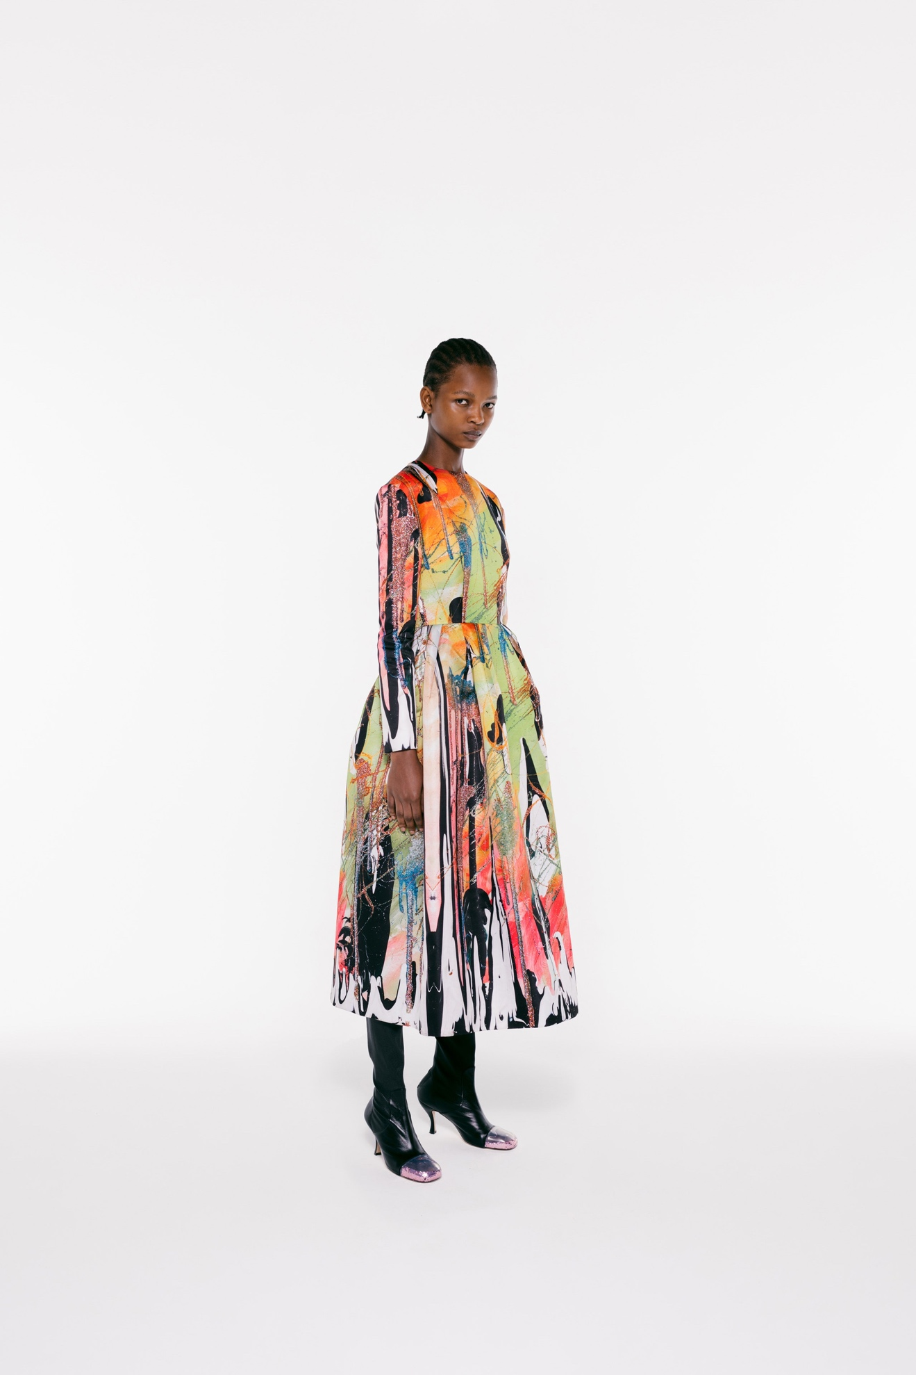Look 1](https://www.vogue.com/fashion-shows/spring-2021-ready-to-wear/christopher-kane/slideshow/collection#1)[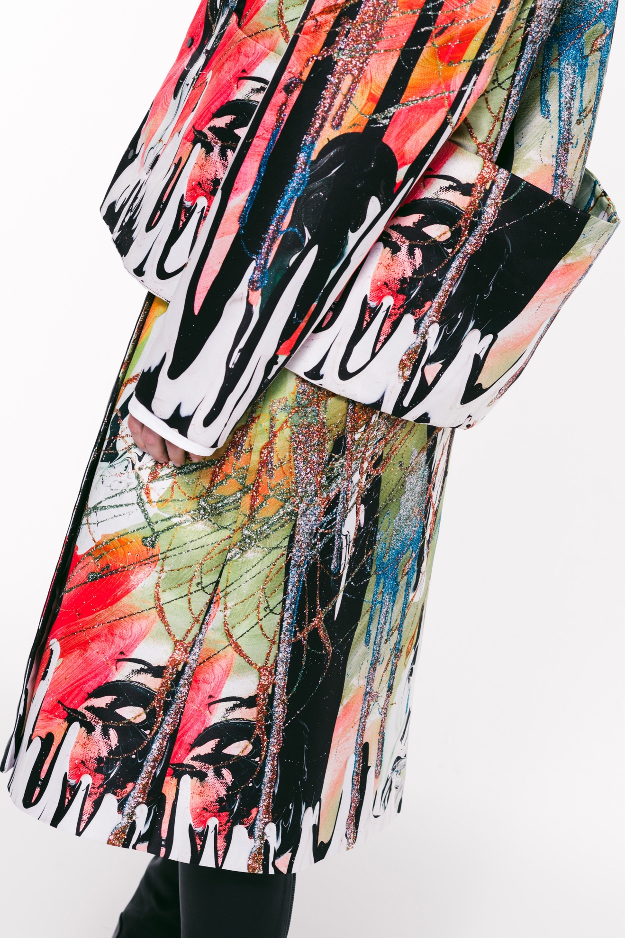Look 2](https://www.vogue.com/fashion-shows/spring-2021-ready-to-wear/christopher-kane/slideshow/collection#2)[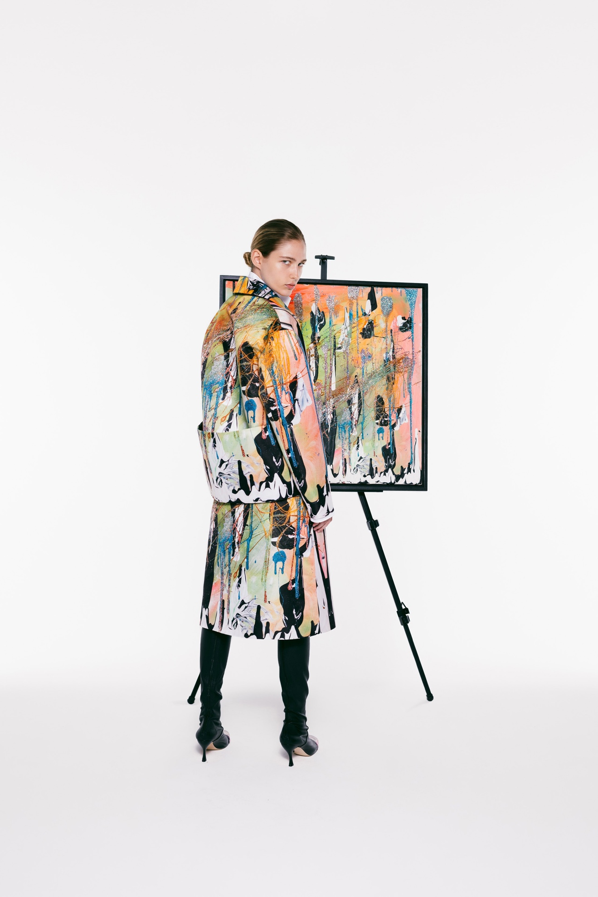Look 3](https://www.vogue.com/fashion-shows/spring-2021-ready-to-wear/christopher-kane/slideshow/collection#3)[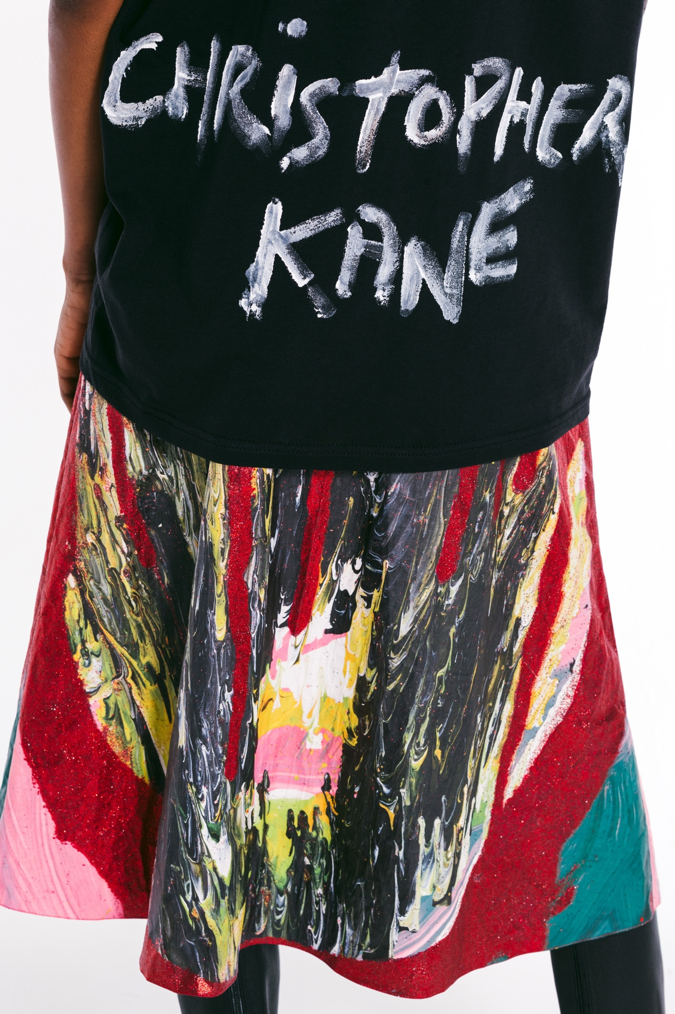Look 4](https://www.vogue.com/fashion-shows/spring-2021-ready-to-wear/christopher-kane/slideshow/collection#4)[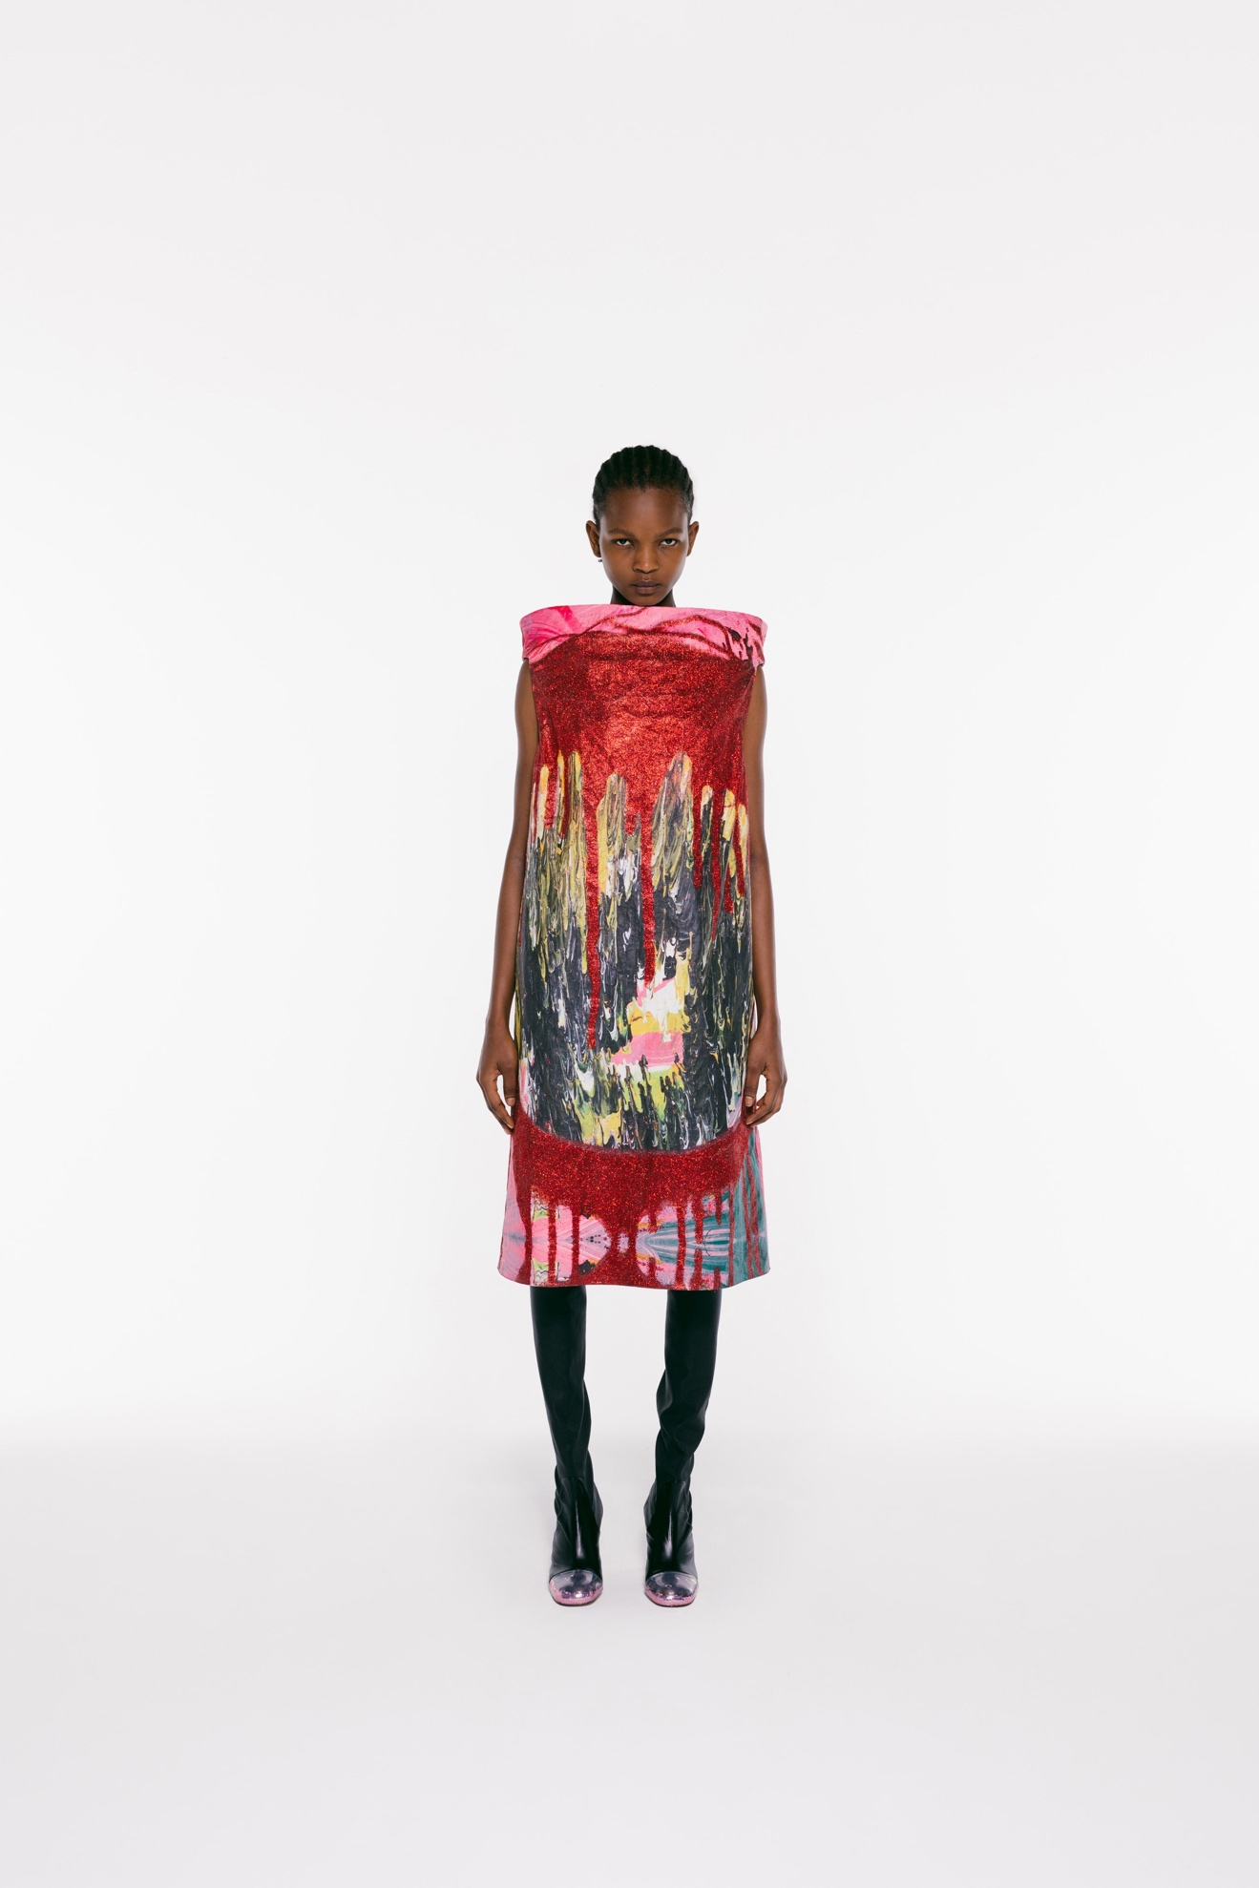Look 5](https://www.vogue.com/fashion-shows/spring-2021-ready-to-wear/christopher-kane/slideshow/collection#5)[Look 6](https://www.vogue.com/fashion-shows/spring-2021-ready-to-wear/christopher-kane/slideshow/collection#6)[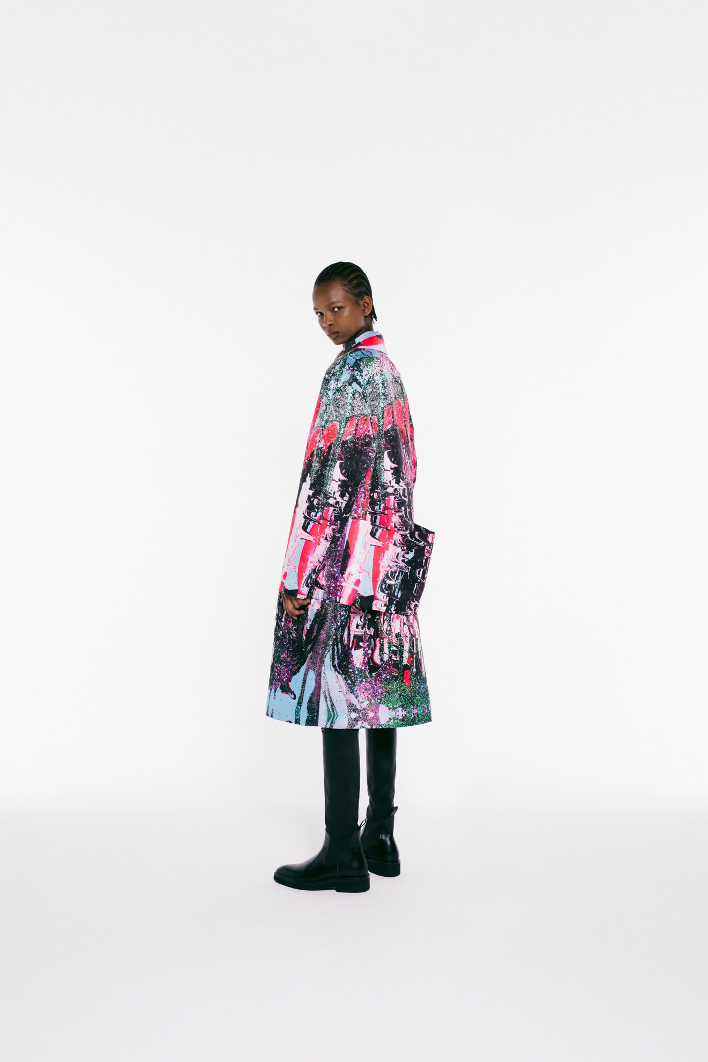Look 7](https://www.vogue.com/fashion-shows/spring-2021-ready-to-wear/christopher-kane/slideshow/collection#7)[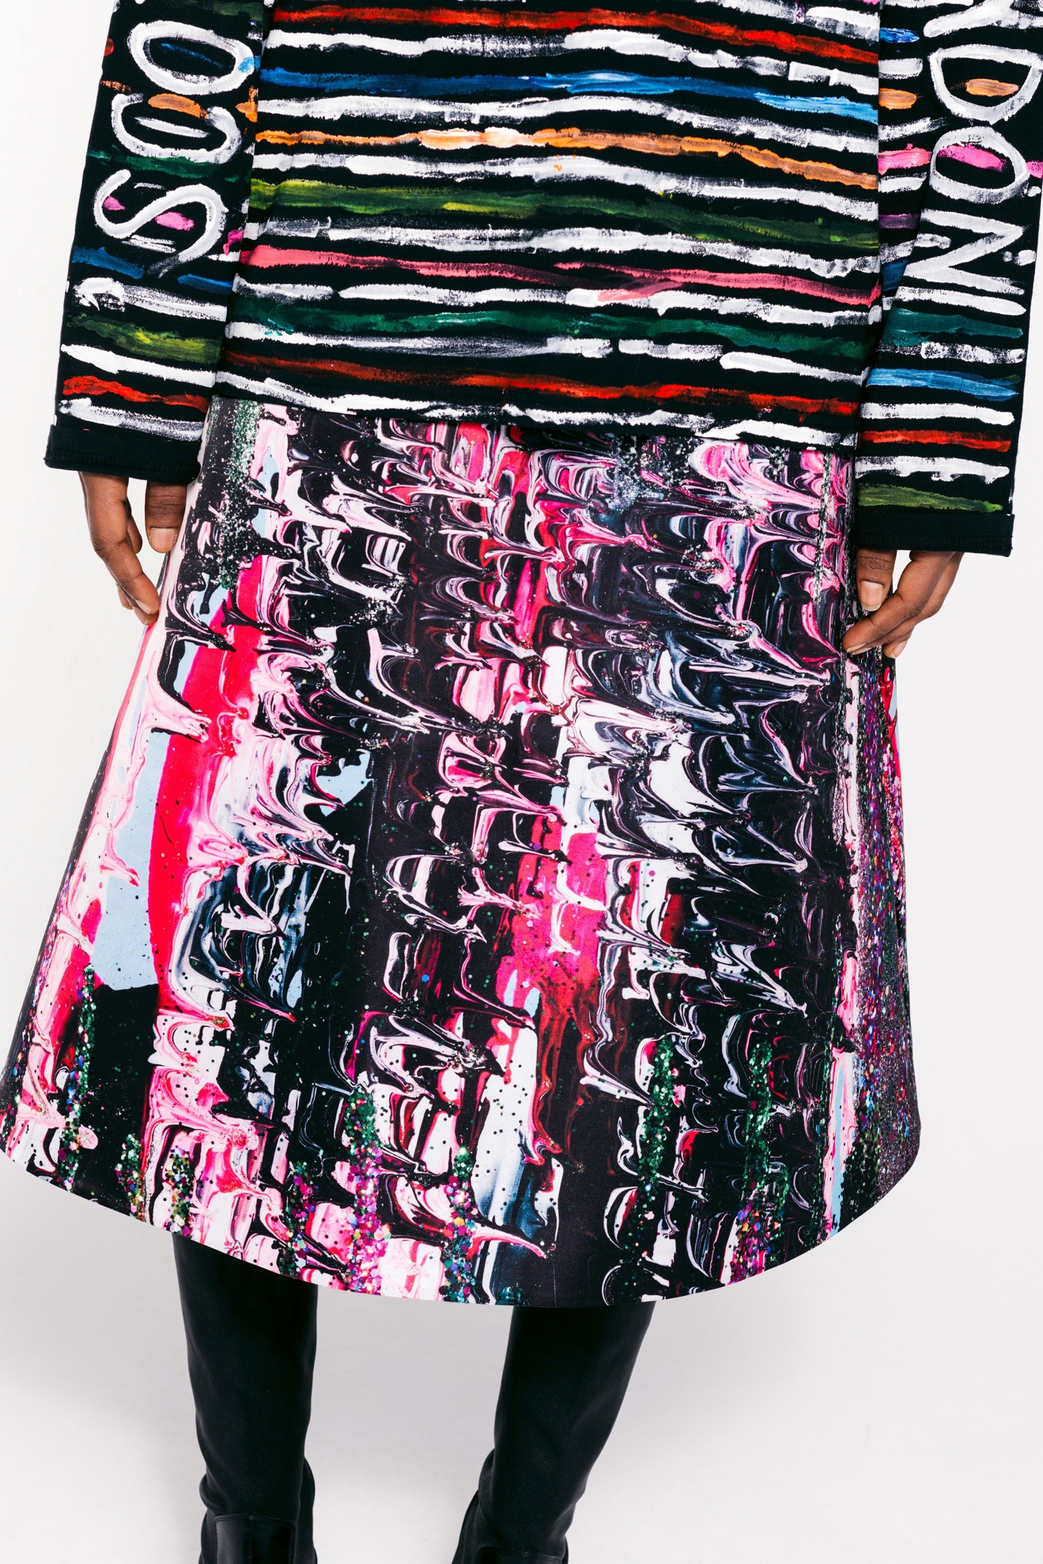Look 8](https://www.vogue.com/fashion-shows/spring-2021-ready-to-wear/christopher-kane/slideshow/collection#8)[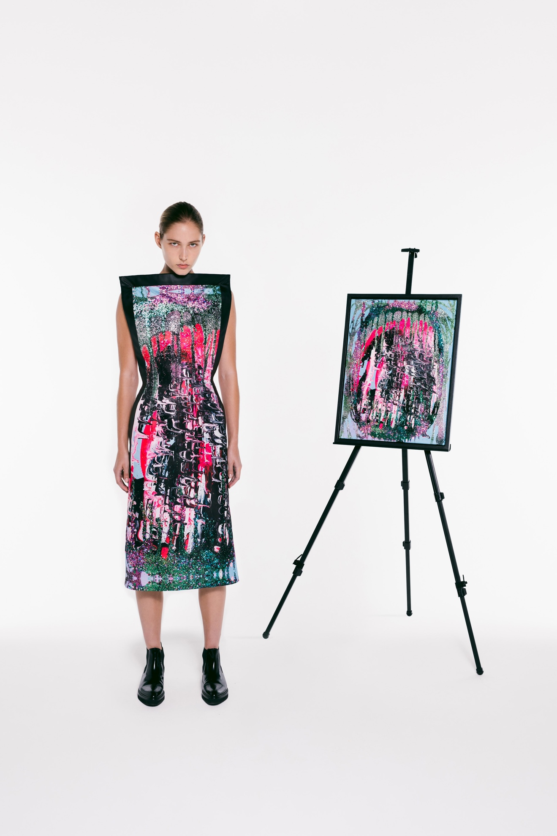Look 9](https://www.vogue.com/fashion-shows/spring-2021-ready-to-wear/christopher-kane/slideshow/collection#9)[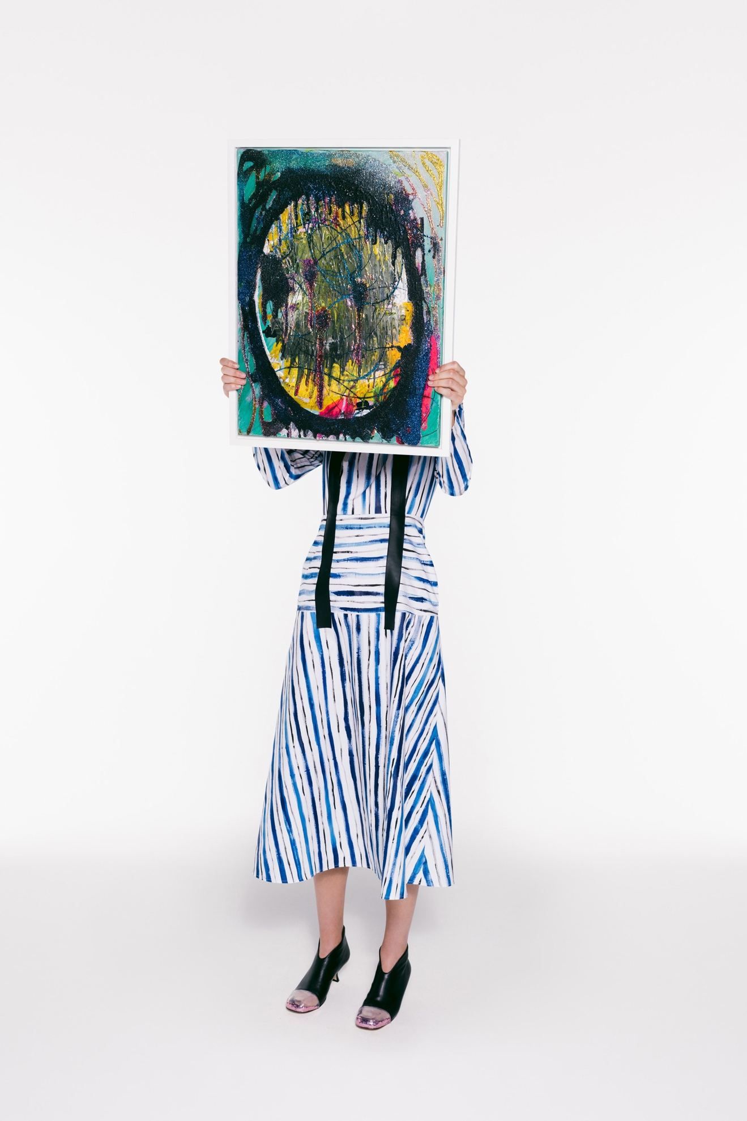Look 10](https://www.vogue.com/fashion-shows/spring-2021-ready-to-wear/christopher-kane/slideshow/collection#10)[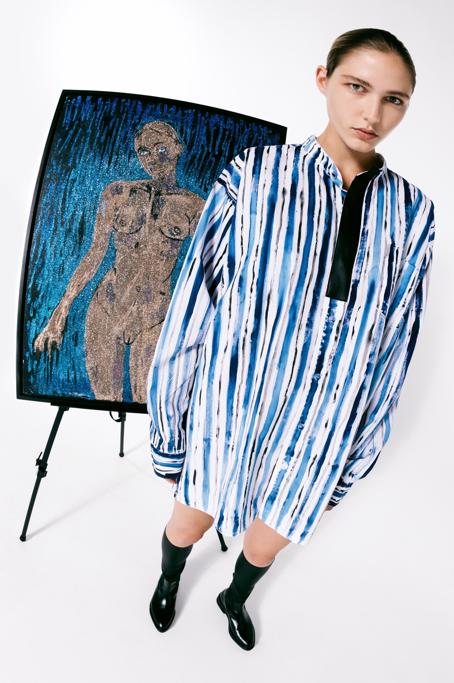Look 11](https://www.vogue.com/fashion-shows/spring-2021-ready-to-wear/christopher-kane/slideshow/collection#11)[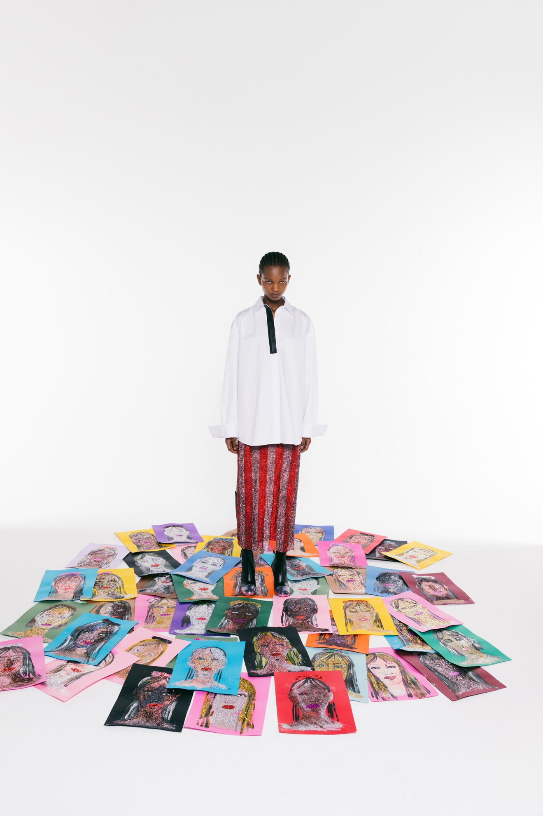Look 12](https://www.vogue.com/fashion-shows/spring-2021-ready-to-wear/christopher-kane/slideshow/collection#12)[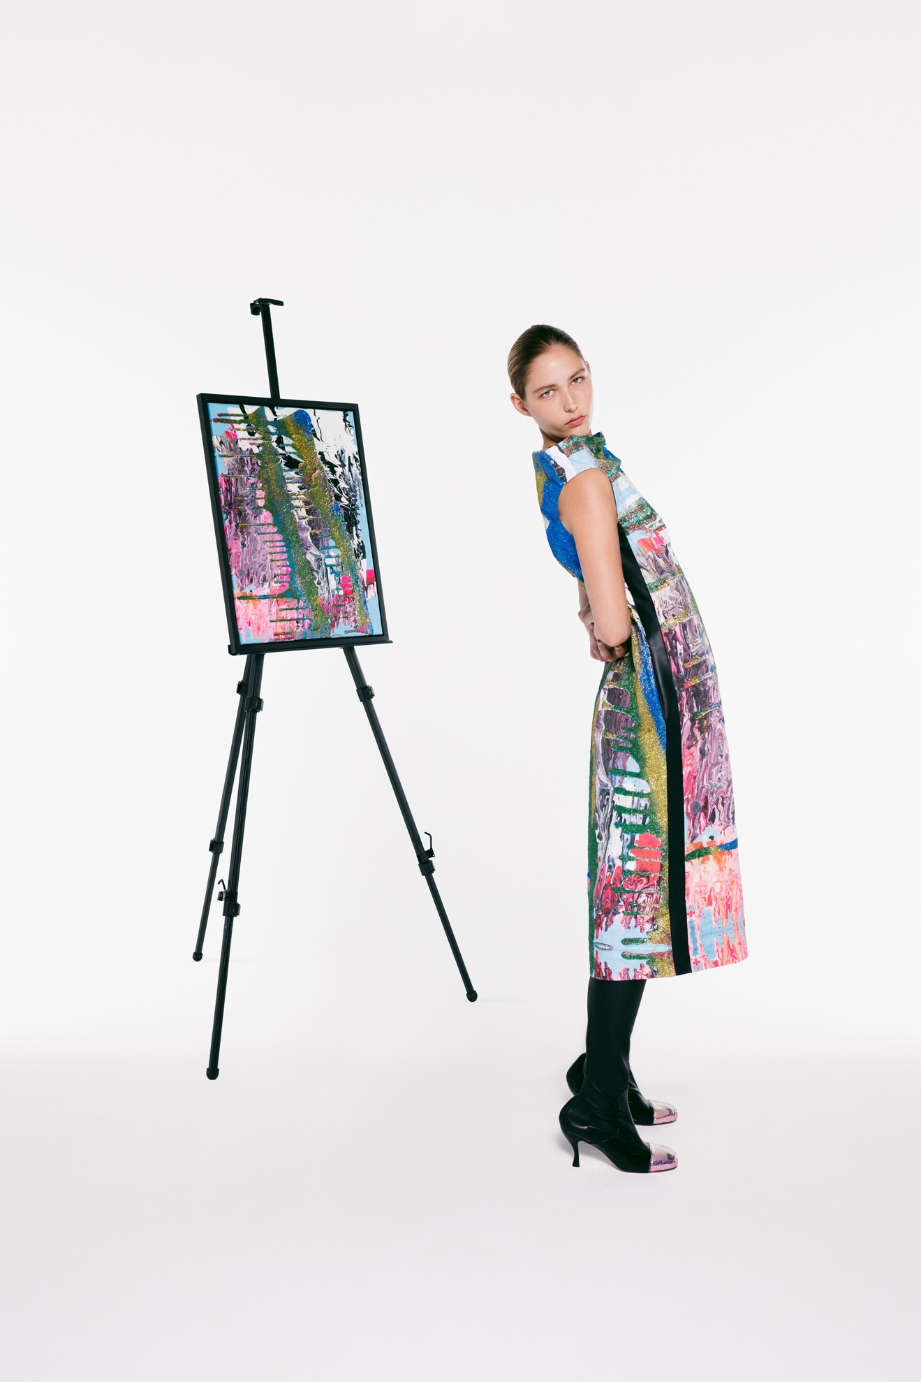Look 13](https://www.vogue.com/fashion-shows/spring-2021-ready-to-wear/christopher-kane/slideshow/collection#13)[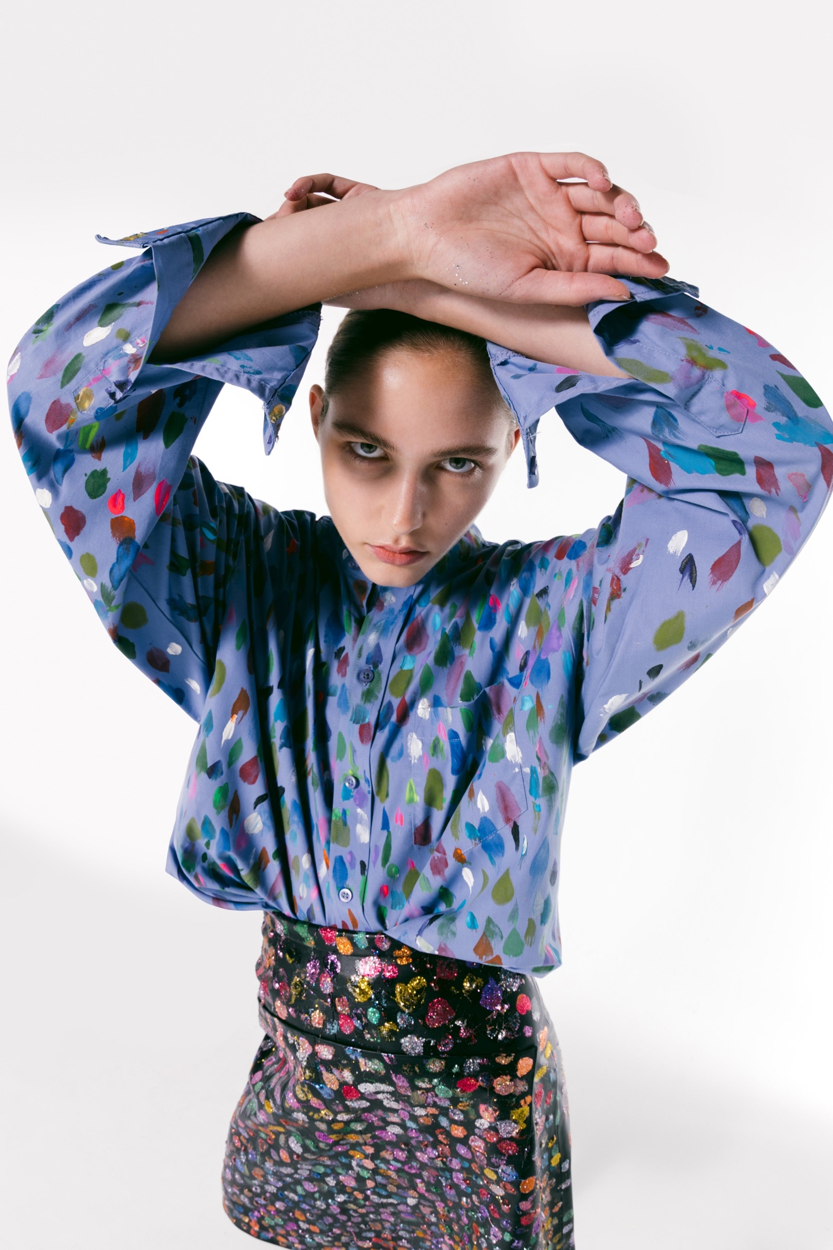Look 14](https://www.vogue.com/fashion-shows/spring-2021-ready-to-wear/christopher-kane/slideshow/collection#14)[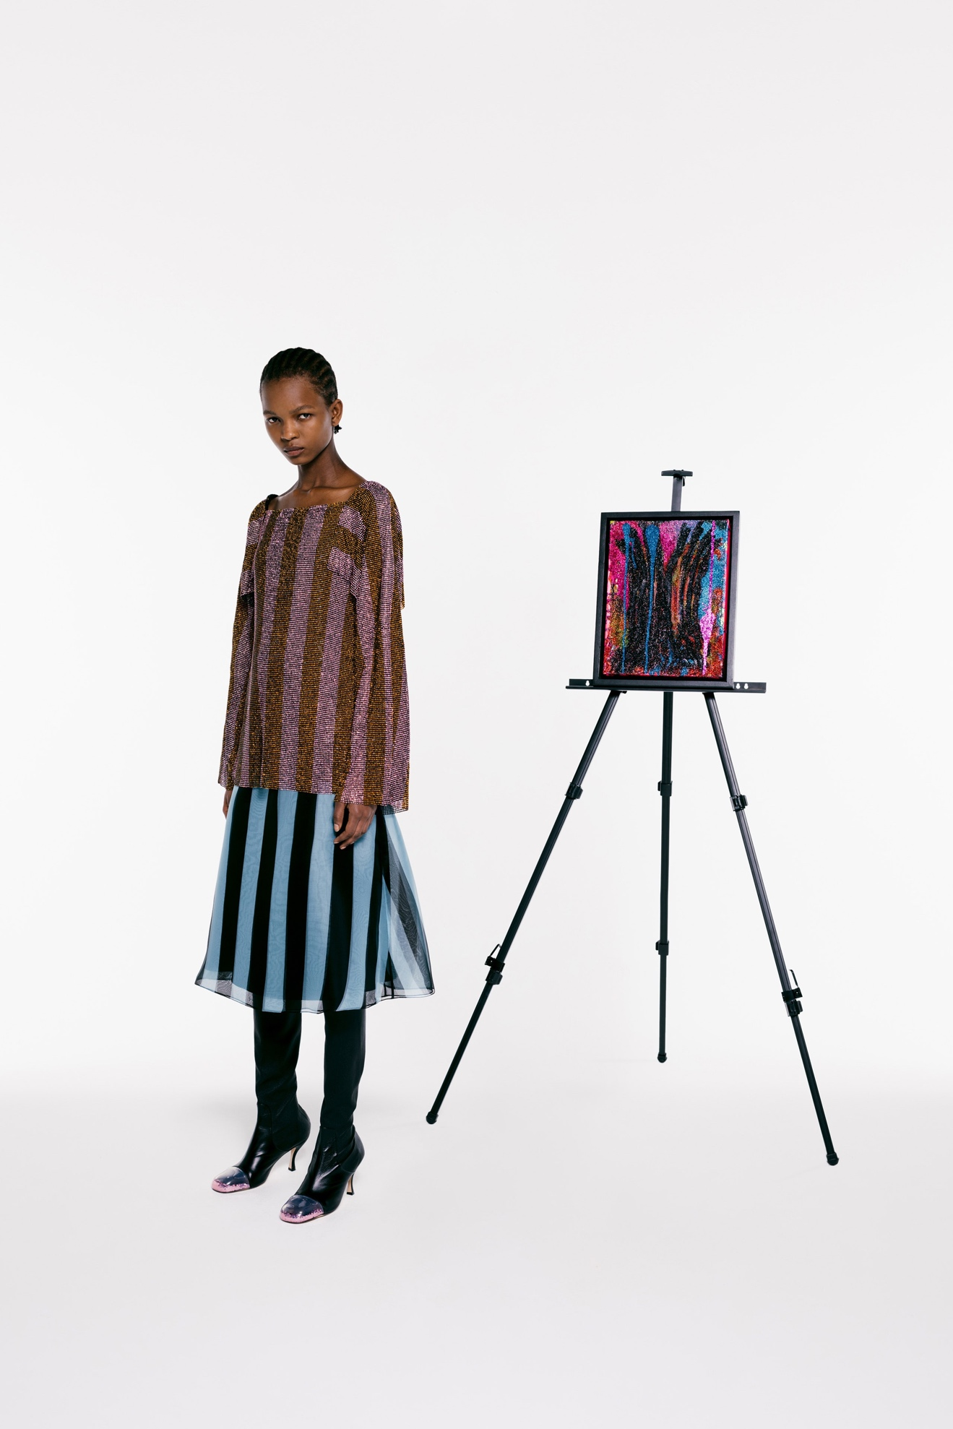Look 15](https://www.vogue.com/fashion-shows/spring-2021-ready-to-wear/christopher-kane/slideshow/collection#15)[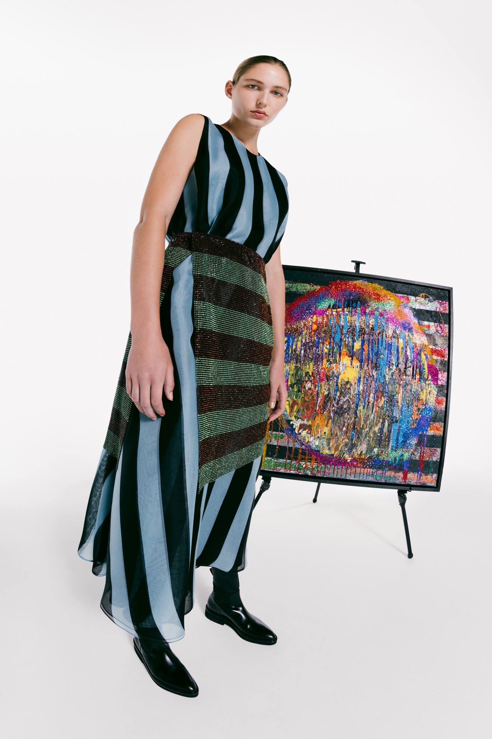](https://www.vogue.com/fashion-shows/spring-2021-ready-to-wear/christopher-kane/slideshow/collection#16)